Welcome Club – End of Year Party
Staff contact: Megan 916-937-1365
Materials
General | Masks, Clip board, snack, water, name tag, hand sanitizer, pens, pencils, markers, check-in sheet
Secret Maze | masking tape/paper plate/paper, drop cloth, ‘map’ of maze
Water balloon toss | water balloons, chalk/cones
Water balloon fight | water balloons, chalk/cones
Water pass | cups, buckets, water, bottle

Welcome Students – 10 minutes
*Boys and girls will check-in at separate classrooms.

- 1 Coach instructs students to line up outside and takes attendance. Be prepared to add new students to the roster. Ask the new student their first name, last name, grade and teacher’s name (if they do not know their teacher’s name that’s ok but the first 3 are a must).
- Remaining Coaches unstack chairs and prep group tables. We will be passing out snacks as students walk in, direct them to their table, etc. Once snacks have been passed out, please put the remaining snacks away for the day. (“Extra” snacks tend to be a distraction to students when left out and available.)
________________________________________________________________________________________________
Welcome: Lead Coach
1st “Welcome to Welcome Club! Today we have a really fun day planned for you! first we need to go over our Welcome Club Agreements! (Use “Four Squares of Treatment” to go over how we treat each other, etc. and transition into next section).
2nd Today we are going to have fun. To have fun we need to be respectful of eachother and listen when there is instructions from the coach.
3rd It is time to clean up our snack! First table with clean desks and quiet arms get to go outside first!
Materials: name tags, sign in sheet, pens

Activity: Secret maze – 20 minutes
Description of activity.
Lead Coach: explains how to play and uses coaches to demonstrate the game.
- A grid will be set up with the starting square clearly marked.
- Table coach will have a paper with a matching grid set up. (only the table coach can look at this paper)
- The 1st student then approaches the grid and steps on the first square.
- The table coach will say safe or out based on the safe path on their paper. Safe=student continues to the next square. Out=Student must go to the back of the line .
- If the square is safe then the student picks a second square to step on. The square the student moves to must be touching the current square the student is standing on. Repeat step 4. The second student then steps on the square the 1st student just left. Repeat until first student is OUT
- When the first student is OUT the second student becomes the leader.

Table Coach: Act as ‘Team Captain’ Encouraging students to remember the places they cannot step and helping their team.
- Table coach has the answer key and will direct the students to make it through the maze.

Bellow are pictures of an example answer key and a student playing the game.
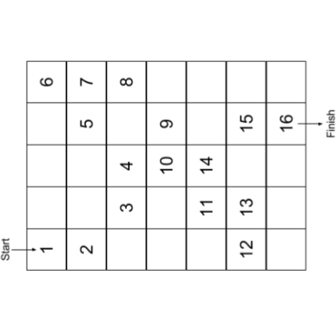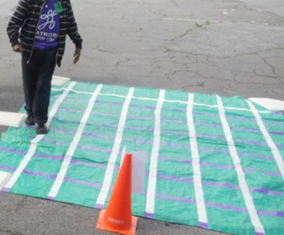
Video of how to play
Materials: masking tape/paper plate/paper, drop cloth, ‘map’ of maze

water balloon toss – 20 minutes
Here is an example of it being played: link
Students will be partnered up and toss the water balloon back and forth. Each time they catch the ball they must take a step back.
Note: mark lines with chalk or cones where the students are supposed to step back to.
Materials: water balloons, chalk/cones

Activity: water balloon ‘fight’– 20 minutes
This is up to coaches. There are two options of how to play this game.

- Students want the least amount of water balloons on their side of the line. They must try to get as many balloon to the other teams side in the designated time.
- Think dodgeball, students throw water balloons at the other team. If you get hit you are out if you catch the balloon your teammate gets to come back in the game.

Materials: water balloons, chalk, bucket

Activity: over head water bucket pass– 20 minutes
Here is an example of it being played: link
Students pass water over their head to the next person. That person then passes water to the person behind them. This repeats to the last person who then pours the remaining water in the bucket. The objective is to fill the bucket to a certain line before the other team.

- 2 teams of 3-6 students stand or sit in a line. Each student has a paper cup.
- The first student scoops up water in their paper cup and pours it over their head into the cup of the student behind then.
- This is repeated for the 2nd student to the 3rd student.
- The last student pours the water over their head into the bucket.

Materials: cups, buckets, water, bottle

Alternative Activity: board games
For students who do not want to participate and get wet take them inside and have them hang out with a coach playing games or coloring.

Materials: board games, markers and coloring books

Clean Up– 5 minutes
Instruct students to pick up and throw away trash before they leave.
- Pick up and throw away trash.
- Sweep floor
- Clean up WC supplies

Please fill out this Survey: https://forms.office.com/r/r1kpc21QTh

